Practicum Case | 
COMP6885 | COMP6885001
Natural Language Processing
Computer Science | O251-COMP6885-FA01-05
Valid on Odd Semester Year 2024/2025 | Revision 00

Learning Outcomes
- LO1 - describe what is Natural Language Processing and its components
- LO2 - explain Explain fundamental concepts of how to work with Natural Language Processing
- LO3 - apply Natural Language Processing concepts in certain real-world applications

Topic
- Session 05 – Sentiment Classification with Naïve Bayes

Sub Topics
- Extract Text Features
- Naive Bayes Classifier
- Save Model to Pickle

Soal
Case
FAtenberg Textionary

FAtenberg Textionary is an application that is used to manage NLTK Texts and WordNet. You as programmer are asked to build the program. There are some requirements that must be fulfilled:
- The program will show the menus. There are 4 menus:
- Get text preview from NLTK
- Get text preview from Web
- Use WordNet
- Exit
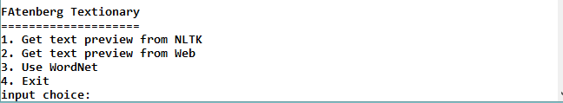
- If user chooses menu 1 ‘Get text preview from NLTK’, then:
  - Validate the user can only choose menu between 1 and 4
  - If the input is 4, then the program will back to main menu
  - Otherwise, show 2 random sentences from the chosen NLTK’s text

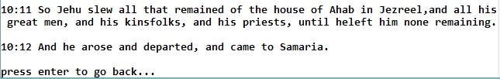
- If user chooses menu 2 ‘Get text preview from Web’, then:
  - Validate the user can only choose menu between 1 and 4
  - If the input is 4, then the program will back to main menu
  - Otherwise, show 2 random sentences from the chosen Web’s text


- If user chooses menu 3 ‘Use WordNet’, then:
  - Ask user to input the number of Web’s text. Validate the input must be a word (cannot contain space)
  - Then, show the synonyms and antonyms of the inputted word
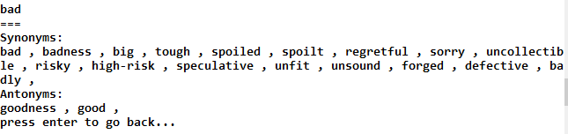
- If user chooses menu 4 ‘Exit’, then the program will exit

Please run the EXE file to see the sample program.

References:
Bible: bible-kjv.txt
William Blake’s poem: blake-poems.txt
Leaves of Grass: whitman-leaves.txt
Wizard of Oz: http://www.gutenberg.org/cache/epub/55/pg55.txt
Return of Sherlock Holmes: http://www.gutenberg.org/cache/epub/108/pg108.txt
Eureka – A prose poem: http://www.gutenberg.org/cache/epub/33397/pg33397.txt

